World Ocean Day: Social Media Toolkit (Education)

World Ocean Day communications pack for education settings
You can use this social media pack and gifs to show your whole school community what your setting is up to this World Ocean Day, whether it’s taking part in class, entering our competition in partnership with World Ocean Day for Schools, raising awareness about the ocean sustainability with your whole school community or showcasing your involvement amongst the online education community.

For education settings and teachers taking part
To use the gif, you can right click and select “Save as picture”. You should be offered the option of saving the file as a gif, and you can then upload this to your channel in the normal way.

Channel | Content
LinkedIn | The ocean is the largest ecosystem on earth and our students are learning that if we look after the ocean, it will look after us.  If you’re a teacher or student, check out the resources from the @Marine Stewardship Council, including these great stickers https://bit.ly/3B5nrP2  #OceanLearning #BigBlueFuture #MSCecolabel
Twitter | The ocean is the largest ecosystem on earth and our students are learning that if we look after the ocean, it will look after us. Check out the resources from the @MSCecolabel, including these great stickers https://bit.ly/3B5nrP2 #OceanLearning #BigBlueFuture #MSCecolabel
Facebook | The ocean is the largest ecosystem on earth and our students are learning that if we look after the ocean, it will look after us.  If you’re a teacher or student, check out the resources from the @MSCecolabel including these great stickers https://bit.ly/3B5nrP2  #OceanLearning #BigBlueFuture #MSCecolabel
Instagram | The ocean is the largest ecosystem on earth and our students are learning that if we look after the ocean, it will look after us.  If you’re a teacher or student, check out the resources from the @MSCecolabel including these great stickers https://bit.ly/3B5nrP2  #OceanLearning #BigBlueFuture #MSCecolabel

For education settings taking a Deep Dive in class
To use the image, you can right click and select “Save as picture”. You should be offered the option of saving the file as a picture, and you can then upload this to your channel in the normal way.

Channel | Content
LinkedIn | We’re excited to go under the surface and learn what a banana, a sticker, taking a holiday and scarecrows have to do with saving the ocean this #WorldOceanDay with the @Marine Stewardship Council https://bit.ly/AnMSCocean  #OceanLearning #BigBlueFuture #MSCecolabel | 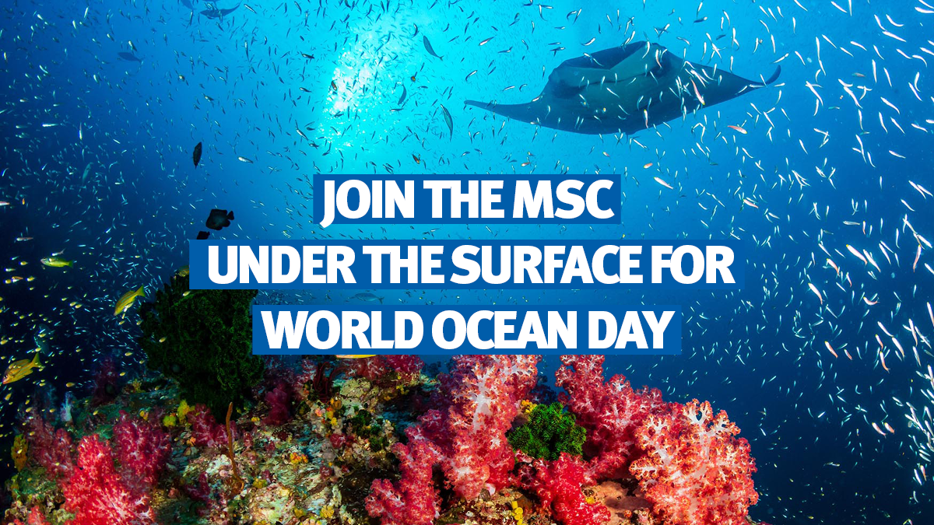
Twitter | We’re excited to go under the surface and learn what a banana, a sticker, taking a holiday and scarecrows have to do with saving the ocean this #WorldOceanDay with @MSCecolabel https://bit.ly/AnMSCocean #OceanLearning #BigBlueFuture #MSCecolabel
Facebook | We’re excited to go under the surface and learn what a banana, a sticker, taking a holiday and scarecrows have to do with saving the ocean this #WorldOceanDay with @MSCecolabel https://bit.ly/AnMSCocean #OceanLearning #BigBlueFuture #MSCecolabel
Instagram | We’re excited to go under the surface and learn what a banana, a sticker, taking a holiday and scarecrows have to do with saving the ocean this #WorldOceanDay with @MSCecolabel https://bit.ly/AnMSCocean #OceanLearning #BigBlueFuture #MSCecolabel #RevitalizeTheOcean | 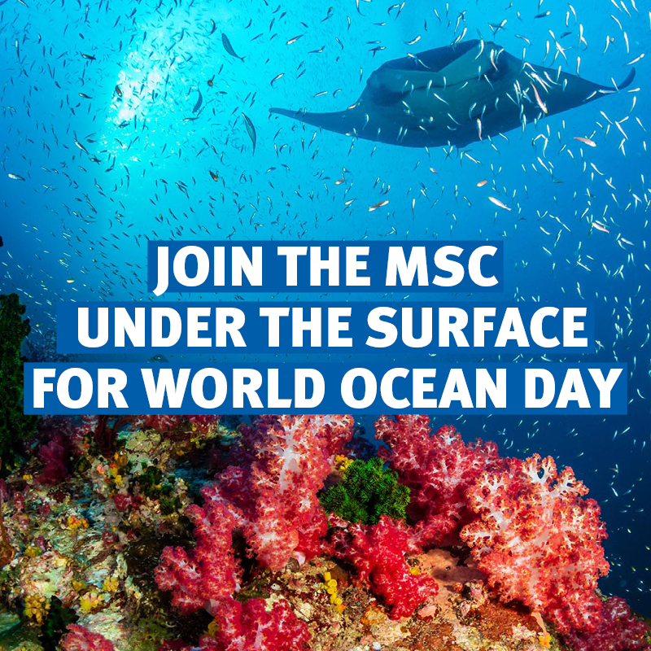

Sharing your competition entry

Channel | Content
LinkedIn | Check out our entry for the @Marine Stewardship Council #WorldOceanDay schools competition! Find out more: https://bit.ly/3B5nrP2  #OceanLearning #BigBlueFuture #MSCecolabel | INSERT Competition Entry Here
Twitter | Check out our entry for the @MSCecolabel #WorldOceanDay schools competition! Find out more: https://bit.ly/3B5nrP2 @wodforschools  #OceanLearning #BigBlueFuture #MSCecolabel
Facebook | Check out our entry for the @MSCecolabel #WorldOceanDay schools competition Find out more: https://bit.ly/3B5nrP2 @worldoceandayforschools  #OceanLearning #BigBlueFuture #MSCecolabel #RevitalizeTheOcean
Instagram | Check out our entry for the @MSCecolabel #WorldOceanDay schools competition Find out more: https://bit.ly/3B5nrP2 @worldoceandayforschools  #OceanLearning #BigBlueFuture #MSCecolabel #RevitalizeTheOcean

Celebrating World Ocean Day
To use the gif, you can right click and select “Save as picture”. You should be offered the option of saving the file as a gif, and you can then upload this to your channel in the normal way.

Channel | Content
LinkedIn  Facebook  Instagram | It’s #WorldOceanDay tomorrow! Get involved and check out what we have in store:  🔹 A virtual deep-sea dive to see how fishers are protecting our ocean  🔹 Practical tips on what you can do to protect the ocean  🔹 Lesson resources for teachers around the world  This and more coming up tomorrow! Follow us and join the conversation: https://bit.ly/MCSWOD  #AnMSCocean #BigBlueFuture #MSCecolabel #SustainableFishing
Twitter | 🌍🌊 It’s #WorldOceanDay tomorrow! Check out what we have in store:  🔹 A virtual deep-sea dive  🔹 What you can do to protect the ocean  🔹 #OceanLearning resources for teachers  Follow us & join the conversation: https://bit.ly/MCSWOD #AnMSCocean #BigBlueFuture #MSCecolabel

