Product Approval Form
- Licensee Details
1.1 Name of licensee

Product Details
2.1 Product name (including product weight):

2.2 Internal product reference
2.3 Barcode (UPC/EAN)
2.4 Chain of Custody certificate code on product
2.5 Latin name(s) of all species used in the product

2.6 Name(s) of MSC-certified fishery/fisheries
2.7 Proposed launch date

- Web site listing
3.1 Please tick one of the following
a |  | Chilled - plain | e |  | Preserved (including canned and dried goods)
b |  | Chilled- prepared | f |  | Surimi (fully cooked fish protein/imitation crab)
c |  | Frozen - plain | g |  | Fish oils
d |  | Frozen - prepared | h |  | Pet food
3.2 Please attach an image of the retail product in web-ready format (600x600, JPEG)
The image will be shown at www.msc.org/product-finder
- Where is this product sold?

4.1 Country/countries
4.2 Sales information
Consumers could buy the product in its current packaging in a retail store, cash & carry market or online.
Please tick the box to confirm.
If this product cannot be available for sales to consumers in its current packaging (e.g. the product will be repacked or unpacked within the supply chain), you don’t need to send the packaging in for approval. Please remember that our guidelines regarding MSC ecolabel use still apply.
- Reminder for the product layout
- Is the MSC Ecolabel on the front of the product packaging?
- Is the Chain of Custody code and MSC claim text on the product packaging?

Thank you for supporting certified sustainable seafood.
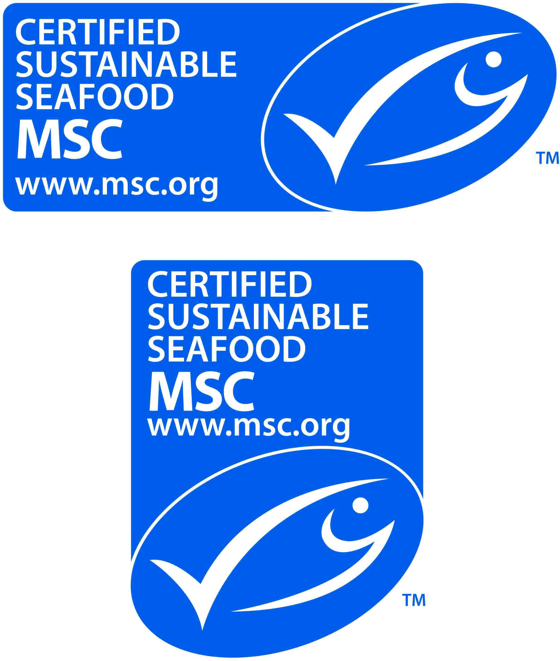

If you have any questions, please contact ecolabel@msc.org.

