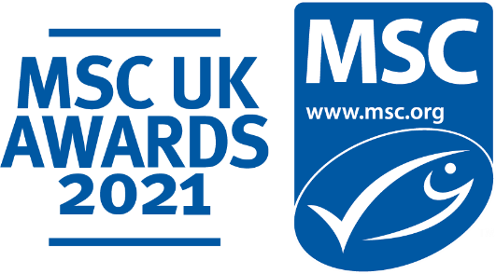

Fresh Fish Foodservice Supplier of the Year
Self-nomination entry submission form

About the MSC UK Fresh Fish Foodservice Supplier of the Year Award

The MSC UK Fresh Fish Foodservice Supplier of the Year Award is presented to a UK-based, MSC certified fresh fish supplier that champions sustainable seafood within the foodservice sector. The category will recognise an outstanding fresh fish supply chain partner who has delivered an exceptional presentation of MSC certified fish and seafood, allowing restaurants and takeaways to serve their customers sustainable dishes, accompanied by the blue MSC ecolabel.

This award category is a chance for you to showcase your efforts in ensuring that there is fresh fish and seafood for future generations and the ocean too, whilst also engaging your customer base with the importance of choosing the blue MSC ecolabel.

An MSC judging panel will be looking for a supplier who goes the extra mile to promote MSC certified products and identify new, fresh, sustainable offerings. This could include bringing new certified species into the market or investing time and energy into supporting the sustainable seafood movement through other initiatives. They will also be looking for a supplier that actively engages with its customer base to educate them about the MSC programme.

Entries open: 1st July 2021

Entries close: 20th August 2021

There is no cost of entry.

Why enter?
- Demonstrate your hard work in bringing sustainable seafood to your customers
- Gain recognition for your commitment to sustainability, innovation, performance and best practice
  - Share and shout about your award win to your partners and customers, in your communications across the coming year
  - Join an ever-growing community of MSC UK Award winners!
Who can enter?
All MSC UK Chain of Custody certificate holders who have sold MSC certified fresh fish and seafood to MSC certified foodservice businesses during the 2020/21 financial year.

Who will be judging this award?
All nominations will be reviewed by an internal MSC judging panel.

Judging Criteria:
Each entry in this category will be assessed against the following three criteria outlined below. All aspects of the criteria are weighted equally with a rating scorecard of 1 to 5. Note: We recognise that the past year has been incredibly challenging for the foodservice industry and those who support it. In your response to the questions below, please feel free to include any ways your business has adapted over the past year and overcome these challenges. We also welcome you to explain any recent long-term commitments to sustainability your business has made.

- Increased awareness of MSC labelled fresh fish and seafood in the UK foodservice sector
Effective use of certification to promote MSC species/products and enhance customer awareness and understanding of certified sustainable seafood

- Promotion of MSC certified products/species and/or introduction of new sustainable offerings
Demonstrable support for MSC certified fisheries through the product and species range promoted to customers

- Sustainable seafood commitment
Clear commitment to increasing the availability of MSC certified fish and seafood now, and in the future

Entry Terms and Conditions
Please complete your entry form and submit to the following email address: mscintheuk@msc.org.

Entry information
This information is for internal MSC judging purposes only and will not to be shared externally.

Fresh Fish Foodservice Supplier of the Year: Entry Form

Company Name: …................................................................................................................

Increasing Awareness
How do you communicate to your foodservice customers about sustainability and the importance of choosing MSC fresh fish and seafood? Please feel free to share any ways in which you promote the benefits of the programme. (Max 500 words)

MSC Certified Range
Please tell us a bit more about your MSC certified product range. What steps were taken by you or your supplier(s) to bring this to your customers? Have you added any new certified products or species to the scope of your range which you are particularly proud of? (Max 500 words)

Commitment to Sustainability
In what way have you demonstrated commitment to sustainable fish and seafood in your fresh fish and seafood product offering? Have you incorporated MSC into your CSR policy or committed to increasing your MSC product range? Are there other projects or initiatives in that your business has invested time or energy which you would like to share? (Max 500 words)

Entry contact Details:
Contact Name:
Contact email:

Thank you for submitting your entry to the MSC UK Awards 2021. We wish you the very best of luck in becoming our MSC UK Fresh Fish Foodservice Supplier of the Year.
We will get in touch if we require further information, and we will, in due course, notify you if your entry has been chosen by the MSC judging panel.

