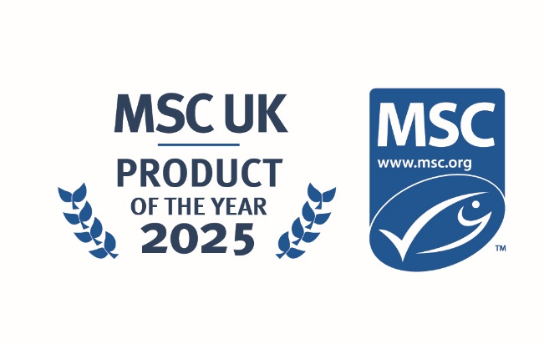

MSC UK Product of the Year
Self-nomination entry submission form

About the MSC UK Product of the Year Award

The MSC UK Product of the Year 2025 will be put to a public vote and will reward exceptional effort in sustainable fish/seafood product innovation in the eyes of the consumer.
The MSC’s Theory of Change is built upon the principle of giving consumers the opportunity to become part of a virtuous circle, helping to protect the productivity and health of our oceans by choosing MSC labelled products.
This award category is a chance to showcase one MSC labelled product that your business or brand is particularly proud to offer to your customers and generate public awareness of the product.
Entry dates:
Self-nomination open: 16th June, 2025
Self-nominations will close: 30th June, 2025
Public voting be open: 14th July – 29th August, 2025
There is no cost of entry.
Why enter?
- Showcase your product innovation and demonstrate the efforts your business has gone to bring certified sustainable seafood to your customers
- Gain recognition for your commitment to supporting certified sustainable fisheries
- Share and shout out about your award win to your customers in your communications across the coming year
- Product promotion across social and media outlets
Who can enter?
All MSC UK partners who have sold an MSC labelled product during the 2024/25 financial year (April 1, 2024 – March 31, 2025). Please note: the product must still be on sale through October 2025.
Entrants may only submit one product entry form. Please note: the product submitted for nomination must have confirmed sales at some point during the 2024/25 financial year in the MSC’s database.
Who will be judging this award?
Public voting will open on the 14th of July. The product with the most amounts of votes will be announced at the awards ceremony in October.

Entry Terms and Conditions
Please complete your entry form and submit to the following email address: mscintheuk@msc.org

Entry information
The following information will be uploaded to the MSC UK website for public voting.

MSC UK Product of the Year: Entry Form

Brand Name:

Product Name:

Product MSC Logo License Number/Barcode:

Product description:
What is the product and what sourcing information are you able to provide. (Max 150 words)

Sustainability credentials:
What do you want consumers to know about the sustainability of the product? (Max 150 words)

Entry contact Details:
Contact Name:
Contact email:

Imagery:
A high-res product shot is required, please attach when sending your entry form.
A high-res company logo is required, please attach when sending your entry form.

See an example of how the voting page, image and text will look via the MSC Polish team Awards

Please note: By submitting this form, you confirm your permission for MSC to use the product imagery and company logo, as well as the descriptions, you have provided, on our website.
Thank you for your entry to the MSC UK Awards 2025. We will get in touch if we require further information. We wish you the very best of luck.

