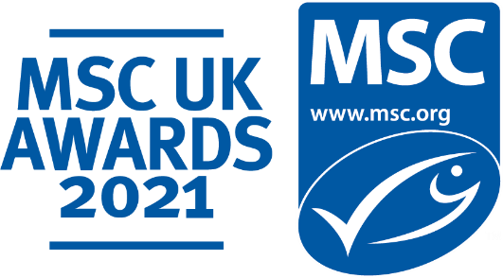

MSC UK Marketing Champion of the Year
Self-nomination entry submission form

About the MSC UK Marketing Champion of the Year Award

The MSC UK Marketing Champion of the Year is presented to an MSC UK partner that has championed the MSC across the 2020-2021 financial year, delivering at least one marketing or advertising campaign which prominently features the Marine Stewardship Council (MSC) and which promotes the importance of seafood sustainability to consumers. The campaign will have demonstrated the partner’s commitment to generating consumer awareness around the blue MSC ecolabel on its products or product range.
This award category is a chance for you to showcase your marketing efforts which feature the MSC and your commitment to communicate to, and engage with, your consumer audiences with fish and seafood sustainability.
An expert MSC judging panel will be looking for highly innovative and inspiring marketing and/or advertising campaigns that champion your marketing and communication efforts.
Entries open: 1st July 2021
Entries close: 20th August 2021
There is no cost of entry.

Why enter?
- Celebrate your marketing achievements.
- Gain recognition for your marketing efforts, your innovation, performance and best practice.
- Demonstrate your hard work and commitment to bringing certified sustainable seafood to your customers.
- Share and shout out about your award win to your partners, clients and consumers in your communications across the coming year and until our 2022 MSC UK Awards.
- Join an ever-growing community of MSC UK Award winners!

Who can enter?
All MSC UK partners who have activated at least one marketing and/or advertising campaign across the 20-21 financial year.
Entrants can present multiple campaigns on different entry forms, one for each campaign you would like to submit for judging.

Who will be judging this award?
The MSC has put together a panel of marketing and communications experts from within its global Marcomms team, as in previous years, and they will be judging the entries using the criteria below.

Judging Criteria:
Each entry in this category will be judged against the following three criteria. All aspects of the criteria are weighted equally with a rating scorecard of 1 to 5.
- Campaign creativities
The campaign has clear, eye-catching and engaging creativities that connect to the ocean and sustainability.

- MSC brand recognition
The effective use by partners of the blue MSC ecolabel, to reach consumers and enhance awareness of the MSC and seafood sustainability.

- Sustainable seafood commitment
The campaign shows clear commitment to promoting and associating the MSC with sustainable seafood and the need to protect seafood supplies for future generations.

Entry Terms and Conditions
Please complete your entry form and submit to the following email address: mscintheuk@msc.org

Entry information
This information is for internal MSC judging purposes only and will not to be shared externally.

MSC UK Marketing Champion of the Year: Entry Form

Company:

Campaign title: …................................................................................................................

Campaign Dates:
- Start date: …............................
- End date: …..............................

Target audience:
Who your campaign was aimed at (age group/ lifestyle/ interests)

Campaign channels:
List and details of the marketing channels used across campaign (TV, in-store, publications, PR, social media, other)

Reach & performance:
The reach and impact the campaign has had. Any information regarding statistics, figures, audience reach, engagement rate.
Campaign creativities:
Please share up to 5 high-resolution images (JPG or similar) to accompany your entry. Images should be the creativities that have been delivered publicly across your campaign.

Please also provide links to any TV spots or other digital activations and social media feeds.

Campaign summary:
Please provide a clear, concise summary of the campaign to support your entry. Share campaign objectives and what marketing/ communication methods were used to get the attention of the target audience and drive your engagement. (Max 500 words)

Entry contact Details:
Contact Name:
Contact email:

Thank you for submitting your entry to the MSC UK Awards 2021 and we wish you the very best of luck in becoming our MSC UK Marketing Champion of the Year.
We will get in touch if we require further information, and we will in due course notify you if your entry has been chosen by the MSC judging panel.

