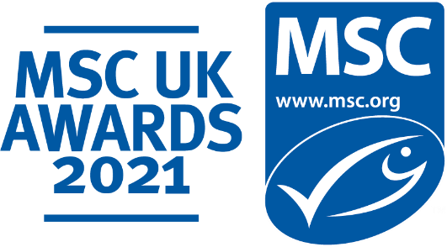

MSC UK Product of the Year
Self-nomination entry submission form

About the MSC UK Product of the Year Award

The MSC UK Product of the Year 2021 is a new award category, presented to a partner who has gone to exceptional efforts in product innovation and demonstrated a strong commitment to recognising and rewarding sustainable fishing practices.
The MSC’s Theory of Change is built upon the principle of giving consumers the opportunity to become part of a virtuous circle, helping to protect the productivity and health of our oceans by choosing MSC labelled products.
This award category is a chance to showcase one MSC labelled product that your business or brand is particularly proud to offer to your customers.
Our independent expert judging panel will be looking for a highly innovative product, that is strongly connected to its source fishery and embodies your brand or business commitment to sustainability.

Entries open: 1st July 2021
Entries close: 20th August 2021
There is no cost of entry.

Why enter?
- Showcase your product innovation and demonstrate your hard work in bringing sustainable seafood to your customers through using the blue MSC ecolabel
- Gain recognition for your commitment to supporting certified sustainable fisheries
- Share and shout out about your award win to your customers in your communications across the coming year
- Become the first of what will be a growing pool of ocean leaders!
Who can enter?
All MSC UK partners who have sold an MSC labelled product during the 2020/21 financial year.
Entrants may only submit one product entry form. Please note: the product submitted for nomination must have confirmed sales at some point during the 2020/21 financial year in the MSC’s database.

Who will be judging this award?
The MSC has put together an independent external panel of expert judges from across the seafood sector. More information on the judges can be found here.

Judging Criteria:
Each entry in this category will be assessed against the following three criteria, outlined below. All parts of the criteria are weighted equally with a rating scorecard of 1 to 5.
- Product innovation
If the product stands out for originality and innovation alongside its use of the MSC label

- MSC label awareness
Effective use by partner of the blue MSC ecolabel and story-telling, to reach consumers and enhance their awareness of the MSC and seafood sustainability

- Sustainable seafood commitment
If the product shows clear support for an MSC certified fishery or species

Entry Terms and Conditions
Please complete your entry form and submit to the following email address: mscintheuk@msc.org

Entry information
This information is for internal MSC judging purposes only and will not to be shared externally.

MSC UK Product of the Year: Entry Form

Brand Name: …................................................................................................................

Product Name: …................................................................................................................

Product MSC Logo License Number/Barcode….............................................................................

Product Launch Date: …................................................................................................................

Product Background:
How did you develop the concept for this product? What made you develop this product? What extra efforts were taken by you or your supplier(s) in order to bring this to customers? (Max 500 words)

Marketing/Communication (if applicable):
Please share any marketing or communication you have made to your customers around this product specifically. (Max 300 words)

Product Details:
Please share what makes you particularly proud of this product, what makes it unique and how you believe it embodies the MSC’s Theory of Change. (Max 500 words)

Entry contact Details:
Contact Name:
Contact email:

Thank you for submitting your entry to the MSC UK Awards 2021. We wish you the very best of luck.
We will get in touch if we require further information, and we will notify you in due course you if your entry has been selected by our external judging panel.

