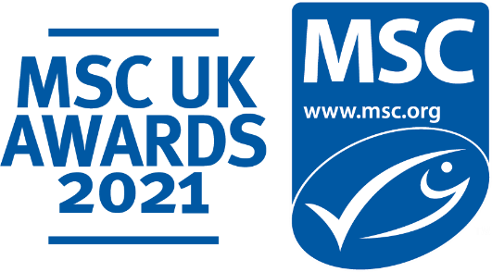

Pet Food Brand of the Year
Self-nomination entry submission form

About the MSC UK Pet Food Brand of Year Award

The MSC UK Pet Food Brand of Year Award is presented to an MSC UK partner that has championed sustainability in the pet food industry during the 2020-2021 financial year.

This award is a chance to showcase your efforts in ensuring that fish and seafood used in your pet food products is good for pets and the ocean too, whilst also engaging your customer base and raising awareness about the importance of choosing products with the blue MSC ecolabel.

An external independent judging panel will be looking for a brand which has gone the extra mile to ensure they are sourcing sustainable fish and seafood and uses the MSC label on their pet food range. This could be through innovation or development of new MSC labelled pet food products, demonstrating an ongoing commitment to sourcing sustainable seafood through providing certified products, and/or actively engaging customers to raise awareness about the importance of the blue MSC label.

Entries open: 1st July 2021

Entries close: 20th August 2021

There is no cost of entry.

Why enter?
- Demonstrate your commitment to bringing sustainable seafood to your customers and their pets
- Gain recognition for your marketing efforts, innovation, and performance around seafood sustainability
  - Share and shout out about your award win; to your partners and customers in your communications across the coming year.
- Join an ever-growing community of MSC UK Award winners!

Who can enter?
All MSC UK partners who have sold MSC labelled pet food during 2020/21 financial year.

Who will be judging this award?
The MSC has put together an independent external panel of expert judges from across the seafood sector. More information on the judges can be found here.

Judging Criteria:
Each entry in this category will be assessed against the following three criteria, outlined below. All parts of the criteria are weighted equally with a rating scorecard of 1 to 5.

1. Promotion of a wide range of MSC certified products/species and/or introduction of new sustainable offerings
Demonstrable support of MSC certified fisheries through the products and species range promoted to customers and their pets.

2. Increased awareness of MSC labelled pet food in the UK
Effective use of certification and the blue MSC ecolabel to reach consumers and enhance their awareness of the MSC and importance of sustainable seafood sourcing.

- Sustainable seafood commitment
Clear commitment to increasing the availability of MSC labelled pet food, now and into the future.

Entry Terms and Conditions
Please complete your entry form and submit to the following email address: mscintheuk@msc.org

Entry information
This information is for internal MSC judging purposes only and will not to be shared externally.

Pet Food Brand of the Year: Entry Form

Brand Name: …................................................................................................................

Communication
Please share any ways in which you have worked to increase awareness about the importance of MSC labelled pet food in the UK. Have you run any campaigns, or any social media or product promotions? If so, what was the reach/performance/consumer engagement? (Max 500 words)

MSC Certified Product Offering
Please tell us a bit more your MSC labelled product offering. What steps have been taken by you or your supplier(s) to bring this to your customers? Have you introduced any new products, used any new MSC species or developed any unique product formats that you are particularly proud of? (Max 500 words)

Commitment to Sustainability
In what way have you demonstrated commitment to using sustainably sourced, MSC certified fish and seafood in your pet food products? Have you incorporated MSC into your CSR policy or committed to increasing your MSC pet food product range? (Max 500 words)

Entry contact Details:
Contact Name:
Contact email:

Thank you for submitting your entry to the MSC UK Awards 2021. We wish you the very best of luck.
We will get in touch if we require further information, and we will in due course notify you if your entry has been chosen by the external judging panel.

